Zababakhin All-Russian Scientific Research Institute of Technical Physics
M.N. Mikheev Institute of Metal Physics, UB RAS
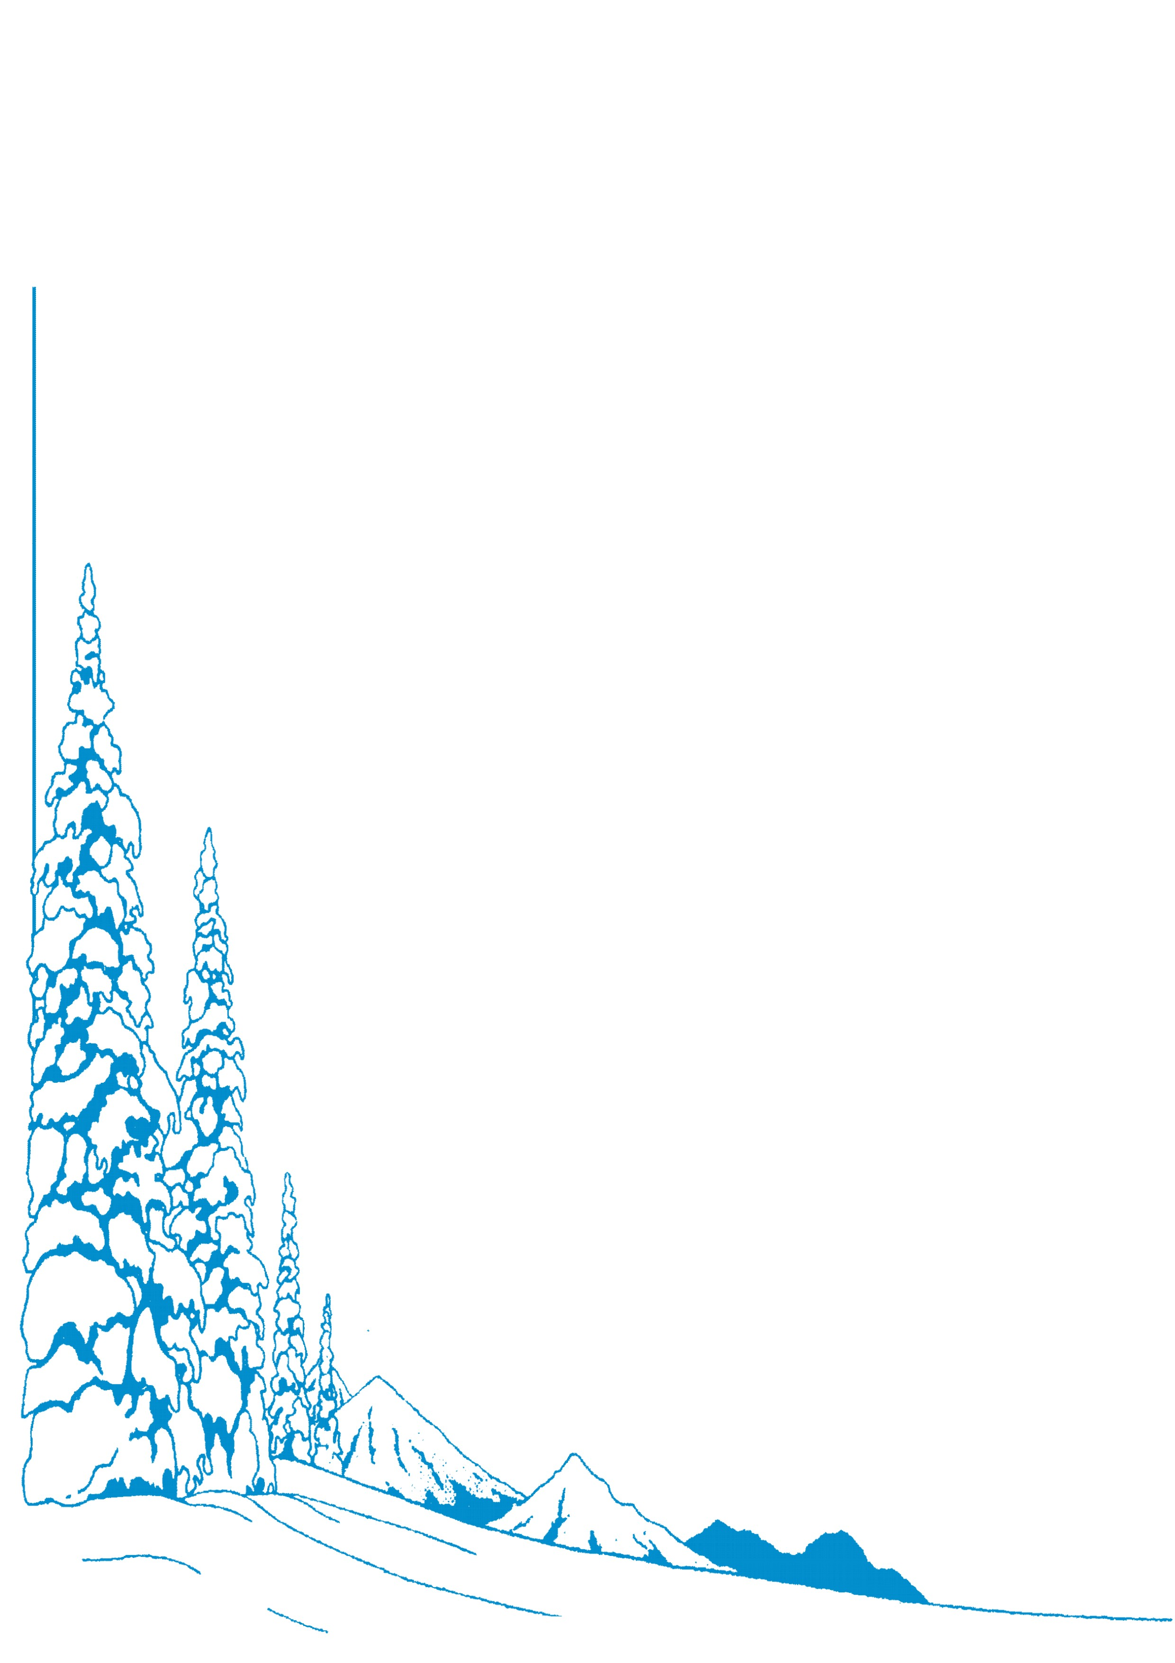
Scientific Board on Radiation Physics of Solids, RAS

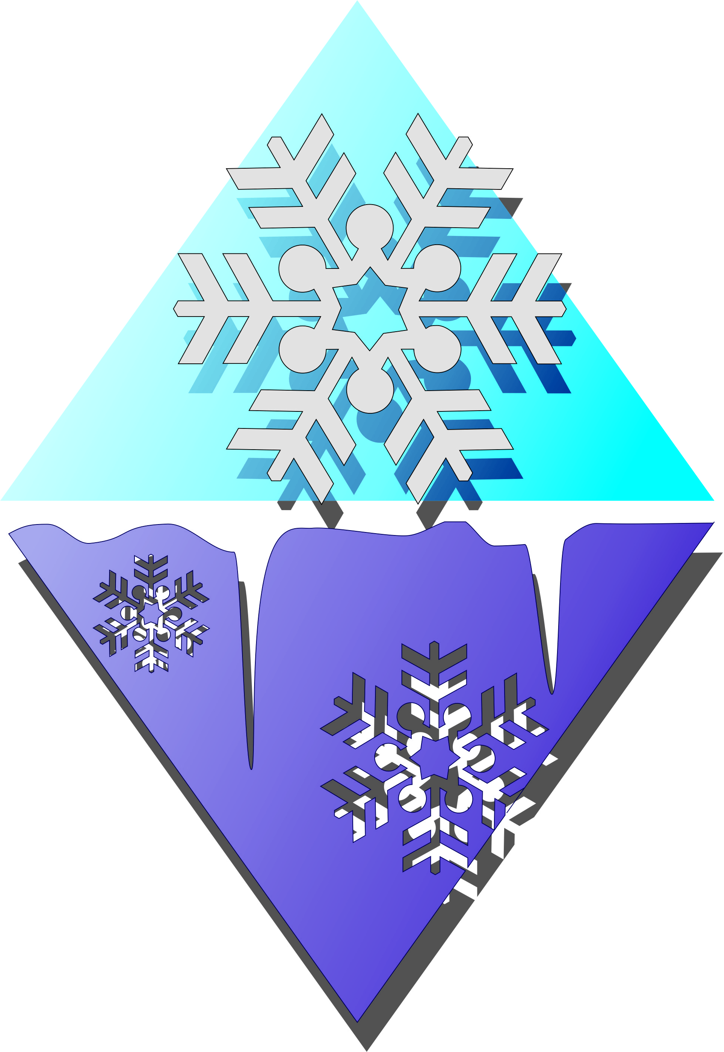

The 12th International Ural Seminar

Radiation Damage Physics of Metals and Alloys

February 27 – March 4, 2017

Kyshtym, RUSSIA

First INFORMATION Circular

Dear Colleagues,
The Russian Federal Nuclear Center – Zababakhin All-Russian Scientific Research Institute of Technical Physics (RFNC-VNIITF), the M.N. Mikheev Institute of Metal Physics of UB RAS, the Scientific Board on Radiation Physics of Solids of RAS are set for arranging the Twelfth International Ural Seminar on Radiation Damage Physics of Metals and Alloys to be held on February 27 to March 4, 2017. The seminar will take place at the Dalnaia Dacha Sanatorium near the town Kyshtym, in the Southern Urals (about 100 km from Ekaterinburg and Cheliabinsk).
Topics for contributions and discussions at the Seminar are planned as follows:
- General problems of radiation damage physics;
- Materials for nuclear and thermonuclear power engineering, new approaches to creation of radiation-resistant structural steels;
- Neutrons, X-ray and bulk studies of advanced materials, including strong-correlatesystems;
- Radiation effects in magnets, superconductors, semiconductors and insulators;
- Radiation technologies for modification of physical-mechanical properties of materials;
- Facilities and techniques of experiment.
Detailed discussions are envisaged on the problems:
- effect of irradiation on changes in microstructure and properties of metals and alloys;
- direct atomistic modeling (molecular dynamics, first-principle calculations) of both the radiation damage and evolution of radiation defects proper, and the properties of materials after radiation exposure, including changes in microstructure, mechanical and thermodynamic properties, and effect of irradiation on electronic structure and magnetic properties;
- specific features of formation of nano- and submicrocrystalline structure of alloys under the radiation and deformation;
- gaseous impurities in irradiated metals and alloys;
- corrosive processes occurring in structural materials in gaseous and liquid metal media at neutron irradiation;
- mechanism of structural changes in various fuel compositions;
- effect of nano- and submicrostructure on the radiation damage of materials;
- effects of irradiation and structural inheritance in actinides, their alloys and model analogs;
- investigations of structural and magnetic properties of perspective materials;
- ordering phenomena, properties of systems with hard fermions and an intermediate valence, superconductivity, phase transitions and electron localizations.
The Seminar will include reports at plenary and section meetings (including invited reports), and poster sessions. Working languages are Russian and English, with simultaneous translation.
Sessions of the traditional Young Beginners’ School will be also scheduled. The age of participants should not be over 35 by the time of the Seminar work. The Young Beginners’ School participants will be exempt from the participation fee.

Organizing Committee
B.N. Goshchitskii  (Co-Chairman) | IMP UB RAS, Ekaterinburg | V.S. Kortov | UrFU, Ekaterinburg
E.N. Avrorin.  (Co-Chairman) | RFNC-VNIITF, Snezhinsk | M.V. Leont’eva-Smirnova | VNIINM, Moscow
V.V. Plokhoi  (Deputy Chairman) | RFNC-VNIITF, Snezhinsk | A.V. Mirmelshtein | RFNC-VNIITF, Snezhinsk
V.V. Sagaradze  (Deputy Chairman) | IMP UB RAS, Ekaterinburg | A.L. Nikolaev | IMP UB RAS, Ekaterinburg
L.S. Talantova  (Deputy Chairman) | RFNC-VNIITF, Snezhinsk | V.V. Ovchinnikov | IEP UB RAS, Ekaterinburg
V.L. Arbuzov (Scientific Secretary) | IMP UB RAS, Ekaterinburg | V.F. Tereshchenko | RFNC-VNIITF, Snezhinsk
V.I. Bobrovskii | IMP UB RAS, Ekaterinbu | A.G. Zaluzhnyi | ITEP, NRNU MEPHI, Moscow
V.V. Dremov | RFNC-VNIITF, Snezhinsk | Yu.N. Zouev | RFNC-VNIITF, Snezhinsk
International Advisory Committee
P.A. Alekseev  (Chairman) | Moscow, Russia | E.M. Ibragimova | Ulugbek, Uzbekistan
F.A. Garner | Richland, USA | M.A. Kirk | Argonne, USA
S.I. Golubov | Oak Ridge, USA | Yu.V. Konobeev | Obninsk, Russia
Program Committee
V.V. Sagaradze (Chairman) | IMP UB RAS | A.L. Nikolaev | IMP UB RAS
V.M. Chernov | VNIINM, Moscow | V.V. Ovchinnikov | IEP UB RAS
V.S. Kortov | USTU, Ekaterinburg | S.V. Rogozhkin | ITEP, NRNU MEPHI, Moscow
A.V. Kozlov | IRM, Zarechny | M.V Sadovskii | IEP UB RAS
M.V. Leont’eva-Smirnova | VNIINM, Moscow | A.G. Zaluzhnyi | ITEP, NRNU MEPHI, Moscow
A.V. Mirmelshtein | RFNC-VNIITF, Snezhinsk
Secretariat
V.L. Arbuzov  (Scientific Secretary) | IMP UB RAS, Ekaterinburg | Celia M. Elliott | University of Illinois at Urbana-Champaign, USA
D.A. Perminov  (Deputy Scientific Secretary) | IMP UB RAS, Ekaterinburg | N.M. Kleinerman | IMP UB RAS, Ekaterinburg
S.Ye. Danilov | IMP UB RAS, Ekaterinburg | E.I. Lavrukova | IMP UB RAS, Ekaterinburg
V.V. Dremov | RFNC-VNIITF, Snezhinsk | A.V. Litvinov | IMP UB RAS, Ekaterinburg
G.M. Solomina | IMP UB RAS, Ekaterinburg

How to apply:
To apply for participation at the Seminar, please send your Registration Form via the e-mail address: RadDamPhys@imp.uran.ru. The deadline for applications is October 1, 2016. The file name should consist of the presenting author’s surname and initials, for example: "SmithAB.doc". At sending applications, please, insert the mark “RegForm” into the Subject,
Please submit the Abstracts of your papers to the address of the Organizing Committee. The deadline for Abstracts, in English, in the form of MS Word files is November 01, 2016. See the Instruction for Abstracts.

Participation fee:
The Seminar Participation fee is $600for Seminar’s participants and $400 for accompanying persons (or equivalent in EU), payable directly at registration in cash. It includes accommodation, paperwork (abstracts processing and editing, Abstracts Book compiling and printing, putting together the Seminar Programme and its printing, preparation and printing of information materials for participants), technical support to oral and poster presentations of papers at the Seminar, transfer from Ekaterinburg to the Seminar’s place and back. The Young Beginners’ School participants will be exempt from the participation fee.

Social programme:
Along with the scientific programme, there will be a welcome reception and a conference dinner. At the Dalnaia Dacha Sanatorium there is a club where entertainments (such as dancing, concert etc.) are regularly arranged. You will be able also to play billiards and to rent a sports kit.

Basic Time Schedule:
October 01, 2016 – Registration submission deadline
November 01, 2016 –Abstracts submission deadline
October 15, 2016 – Invitation Letter
February 1, 2017 – 2nd Information Circular
February 27, 2017 – Arrivals, check-ins
March 5, 2017 – Departures

Secretariat Address:
Vadim Arbuzov
Ural Seminar  Institute of Metal Physics UB RAS  18 S. Kovalevskaia Str.  620137 Ekaterinburg, Russia | phone: +7-343-3783538, 3783850  fax: +7-343-3740003  e-mail: RadDamPhys@imp.uran.ru  http://impo.imp.uran.ru/radiation

The Organizing Committee will be very grateful to Organizations, Funds, and individuals who can give sponsorship support to our Seminar.

